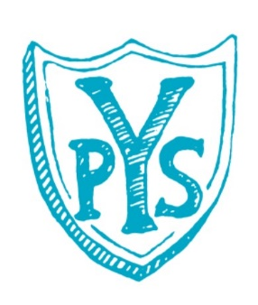
Yass Public School P&C Association

Uniform Shop Order Form

NAME:__________________________________ PHONE: _________________

CHILD’S NAME: ________________________________ CLASS: ___________

PRODUCT | PRICE | SIZE | QUANTITY | TOTAL
Polar Fleece Zip Jacket | $35.00 |  |  | $
Hoodie Jacket | $35.00 |  |  | $
Wet Weather Jacket | $40.00 |  |  | $
Polar Fleece Vest | $25.00 |  |  | $
Tracksuit Pants | $22.00 |  |  | $
D/Knee Tracksuit Pants | $24.00 |  |  | $
Microfibre Tracksuit Pants | $24.00 |  |  | $
Gaberdine Long Pants | $22.00 |  |  | $
Gaberdine D/Knee Pants | $24.00 |  |  | $
Girls Boot leg Pants | $21.00 |  |  | $
Red Short Sleeve Polo | $20.00 |  |  | $
Red Long Sleeve Polo | $22.00 |  |  | $
Red/Blue Sports Shirt | $30.00 |  |  | $
Gaberdine Shorts Boys/Girls | $18.00 |  |  | $
Microfibre Shorts | $18.00 |  |  | $
Gaberdine Cargo Shorts | $19.00 |  |  | $
Netball Skirts | $20.00 |  |  | $
Girls Skort | $20.00 |  |  | $
Girls Sport Skirt w Short | $17.00 |  |  | $
Girls Dress | $45.00 |  |  | $
Broad Brim Hat | $10.00 | S/M/L |  | $
Bucket Hat | $10.00 | S/M/L |  | $
Beanie | $10.00 | One size |  | $
Total Enclosed |  |  |  | $

SIZE | 4 | 6 | 8 | 10 | 12 | 14 | 16
Height | 110cm | 120cm | 130cm | 140cm | 150cm | 160cm | 170cm
Chest | 60cm | 64cm | 68cm | 72cm | 76cm | 80cm | 86cm
Waist | 56cm | 58cm | 60cm | 64cm | 68cm | 72cm | 76cm
Please enclose money or cheque made out to Yass Public School P&C Association.

